INTRODUCTION

* 1. Overview : A brief description about your project .
  2. Purpose : the use of this project . what can be achieved this.

##### Problem Definition & Design Thinking.

This Global Air Transportation Network dataset is a comprehensive collection of information on airports, airlines and their routes. It contains information such as names, cities, countries, codes (IATA and ICAO) longitudes, latitudes and altitudes of airports across the world with detailed time zone and daylight saving time data. Additionally, this includes information about airlines including their IDs, name aliases, IATA and ICAO codes, callsigns country of origin and active/inactive status. Similarly, it also covers route details such as airline sources to destination airports along with essential details like codeshare stakeholder if any stops required during this journey along with the type of aircraft being used for that particular journey. This dataset has been compiled through meticulous labor by researchers all over the world to give you a comprehensive detail into air transportation networks from around the globe.

**Technical Architecture:**



**EXPLAIN DATA AND AIR TRANSPORT**

**Big data: Unlocking the value of data in air transport**

The right data, harnessed in the right way, can deliver actionable insights that are truly transformative for decision-making, efficiency and smooth passenger-focused delivery of services. Jim Peters, Chief Technology Officer at SITA, reveals how big data is beginning to deliver real value in the air transport industry.



You can already see many examples of where data-driven business intelligence (BI) initiatives are transforming the way things are done in the air transport industry. Investment in BI is critical if the maximum value is to be obtained from the vast volumes of data increasingly available to airport and airline management. It’s about capturing, collating and, importantly, analysing the data. That’s what leads to greater productivity, effectiveness and, ultimately an enhanced customer service.

**STRUCTURE OF AIRLINES**

The typical organizational structure of an airline includes operations, maintenance, marketing, and finance divisions. The operations division manages the day-to-day activities of the airline, overseeing the pilots and flight attendants, the flight dispatchers, flight scheduling, and ground crews.

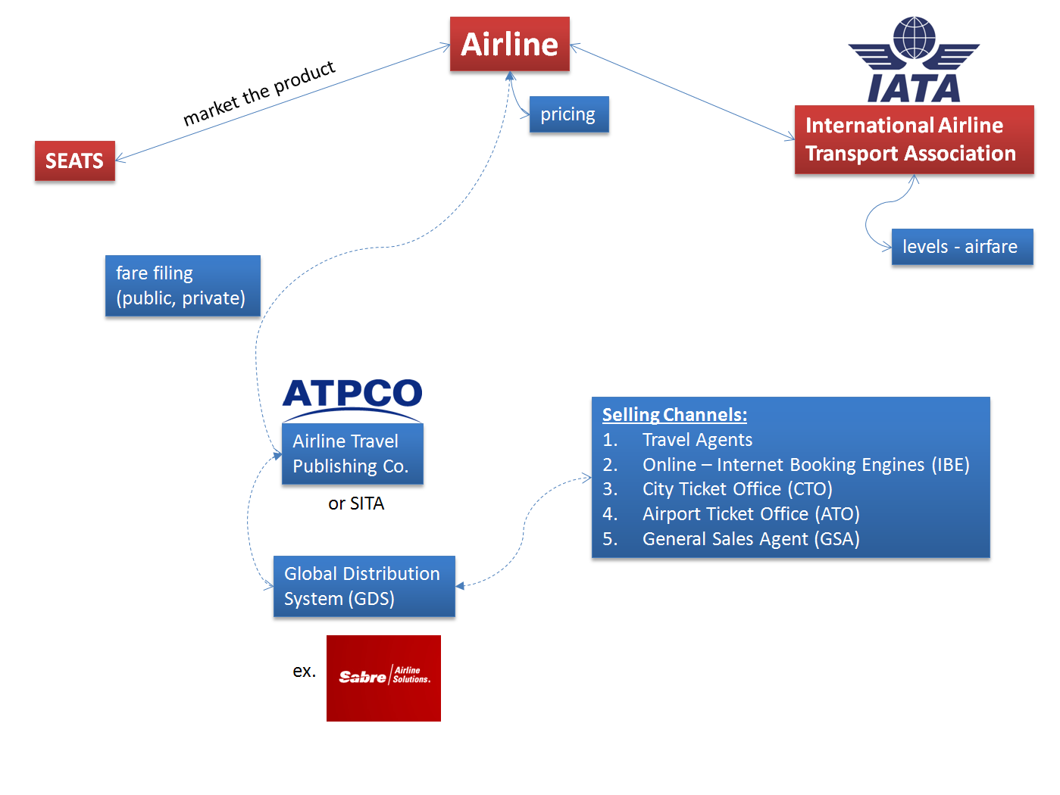

## Studying the Impact of the Organizational Structure on Airline Operations Control - ScienceDirect

## Data at airports

As passenger volumes increase faster than new airports or terminals can be built, demand is placed on airport management for more complex and timely decisions. Costs must be controlled, productivity must be improved and security enhanced. And all of this must be done at the same time as meeting the increased expectations of passengers for smooth and efficient services which ensure hassle-free travel.

BI tools – such as SITA’s Day of Operations BI – are becoming central to that delivery. They enable extensive data sourcing and understanding of the relationships between data sets, and analyse and establish context, before identifying areas for change and improvement. At the same time, the technology provides the reasoning to underpin decisions. The success of BI depends on the collaboration and co-operation of all stakeholders. It should make use of the widest range of data sources. These include Wi-Fi, Bluetooth, video/biometrics, airport operational databases, common-use systems, baggage systems and customer satisfaction monitoring systems.

Collaborative decision making (CDM) is top of the agenda at many airports today. Its goal is to improve overall efficiency of operations by working with different stakeholders to integrate processes and systems to reduce delays and better manage airport resources. The priority of CDM programs has typically been to keep to the fl ight schedule with on-time departures, closely associated with ensuring aircraft turnaround times. A more enhanced version of CDM – Airport-CDM (A-CDM) – connects the airport into regional air traffic management, as well as the airlines’ systems and those of other relevant partners. A-CDM is a joint program between ACI EUROPE, EUROCONTROL, IATA and CANSO that aims to improve the overall effi ciency of airport operations by optimising the use of resources and improving the predictability of events. SITA provides the mandatory modules, integration capabilities and consultancy to drive the organisational changes required to achieve A-CDM compliancy according to EUROCONTROL’s definition.

Both CDM and A-CDM require accurate, real-time information so they can provide a ‘single version of the truth’ for all airport stakeholders. The best way to ensure that is through an integrated control centre, which are becoming increasingly common at major airports and are beginning to be implemented at medium and smaller airports. They are designed to dissolve the silos so that an airport can coordinate, monitor and control operations at one decision-making point.

At first, BI solutions in airports typically focused on issues such as revenue optimisation. But the focus has been shifting as more BI tools are developed and as the pressure on airports increases. Airports want to use BI tools to monitor passenger flow, and deploy staff and assets more effectively, including the ability to exploit aircraft movement data. CDM and A-CDM are critical parts of that process.

A growing roster of enhancements provides ample evidence of the power of data to drive improvements. They include the introduction of real-time fl ow prediction, like that enabled by SITA’s FlowPredictor solution. It has helped a leading European airport cut waiting time at process points by 20 per cent and increase passenger satisfaction by 10 per cent. All that comes from having an accurate view of predicted passenger flows as forecasts are performed continuously, always using the current situation in the airport, and reflecting any change within minutes when updating forecasts.

There’s also the ability to analyse queues for monitoring, measuring and projecting queue wait times. Orlando International Airport is a great example of how linking BI with a tool such as SITA’s QueueAnalyzer can help reduce traveller stress and deliver more accurate resource planning. After installation, the airport experienced shorter wait times, with 53 per cent few passengers spending more than 15 minutes in line. The new system resulted in the double benefit of reducing stress for travellers while enabling more accurate resource planning by the airport.

Just as the benefits of integrating operational data into a single system are clear to all, at the other end of the spectrum, it’s every bit as important to share information and data between airport-based staff. Silos need to be removed at all levels of the organisation: better staff collaboration must be dependent on sharing information and making data available to all as needed.

One way of achieving this is through a workforce mobility solution, such as SITA’s AirsideApp, that allows ground processes to be moved from paper to digital and from desktop to mobile. It is tablet-based and connects to airline, airport and ground handler systems, so information can be collected and shared in real-time. The AirsideApp is currently used by airports in Asia and the Middle East, where it’s been shown to reduce the administration time needed to process forms and manuals by as much as 30 per cent, and to increase the accuracy of time-stamped activity recording by up to 25 per cent.

**Data in the skies**

As with airports, airlines and aircraft are harnessing the power of data.

Out on the runway and up into the skies, aircraft have never generated more complex data. Aircraft data parameters have sky-rocketed, almost beyond comprehension, from just five, to more than 200,000 today. It has clearly never been more critical for airlines to master how to manage their fleet data and maximise its value. This has positive implications for every aspect of the aircraft, from unlocking enhanced passenger, cockpit and cabin crew experiences and more efficient flight operations and maintenance, to more effective ground-handling.

So where does this impressive volume of aircraft data come from? It’s in the constant hum of aircraft communications, and the engine health and performance data collated at every stage of flight. It also includes passengers’ connections to inflight internet and mobile network services, the cockpit’s correspondence with airline ground operations and air traffic control, cabin crew communication with central airline customer relationship management teams… nearly every activity or decision carried out onboard an aircraft generates data.

SITAONAIR, SITA’s expert in complete, nose-to-tail services for the connected aircraft, is focused on empowering the industry to harness and analyse this data. And in doing so one of the key benefits is delivering a more personalised passenger experience. One way of doing that is to integrate the airline’s CRM system with the inflight connectivity portal, enabling the airline to deliver customised inflight connectivity offers to selected passenger demographics.

**What’s on the horizon?** The future of disruption management at airports looks set to change thanks to more intelligent use of data. Airports will no longer exclusively manage disruption reactively, they’ll be able to predict disruption before it even happens. SITA Lab is working on new disruption tools that use artificial intelligence (AI) and big data to make it a reality.

These tools will be able to provide an enhanced look forward up to 72 hours in advance, enabling an airport or airline to be prepared and ready for any anticipated disruptions and, where possible, deliver proactive problem prevention and mitigation. We can take a whole set of historical data, feed it into a neural network, an AI model that emulates the human brain. The more data, the better. It’s based on a theory that history is going to repeat itself in areas such as weather, runway conditions and runway operating directions.

Baggage management is another area where AI and big data could combine to transform things as we currently know them. From an operations point of view, AI will allow airports and airlines to analyse data to learn what baggage routes cause the most stress on their systems and what factors are most likely to cause them. These systems could also generate insight into the patterns of baggage movements that would enable airlines to deliver bags more effectively.

SITA has a unique role to play in realising the potential of data. We are the world’s leading facilitator of air transport data exchange, including the switching of 30 billion industry messages a year. Managing much of this data around airport and aircraft operations, we are the vital link for many industry processes involving multi-stakeholder collaboration.

We’re working closely with the world’s airports, airlines and ground handlers – as well as governments – to make sure they can make the most of all the data at their fingertips to improve the passenger experience and operational processes at all airports for all airlines. Together, we are unlocking the value of air transport data.

## EMPATHY MAP

## 

## 

Use this template in your own brainstorming sessions so your team can unleash their imagination and start shaping concepts even if you're not sitting in the same room.

Brainstorming provides a free and open environment that encourages everyone within a team to participate in the creative thinking process that leads to problem solving. Prioritizing volume over value, out-of-the-box ideas are welcome and built upon, and all participants are encouraged to collaborate, helping each other develop a rich amount of creative solutions.

**The Brainstorm & idea prioritization template helps you:**

* Prepare for your brainstorming session
* Define your problem statement
* Collect ideas and gather feedback from everyone
* Group ideas by theme
* Prioritize your solutions and get aligned on next steps

## How to use the brainstorming & idea prioritization template

To use the Mural brainstorming & idea prioritization template with your team, follow the steps outlined below.

### 1. Define goal and invite stakeholders

The first step in the process is to clearly define the goal(s) of your brainstorming session. What problem(s) are you trying to solve? At this stage, you should also carefully select a list of stakeholders who will participate in your brainstorming session.

### 2. Define your problem statement

The next phase is to create a problem statement that clearly identifies the issue. Frame your problem statement as a ‘How might we?’ question (e.g., ‘How might we shorten wait times for customer service calls?’).

### 3. Brainstorm!

Have each stakeholder brainstorm as many ideas for possible solutions as they can in a given time.

Pro-tip: Use Mural’s private mode feature to avoid groupthink while brainstorming, allowing everyone to work independently even while synchronous.

### 4. Group ideas together by theme

Once you’ve generated as many ideas as possible with your team, it’s time to look carefully at the results. What are the natural themes that emerge from your ideation? How should they be grouped together to inform potential solutions?

### 5. Prioritize solutions

Now that you’ve refined your ideation into themes, you can effectively prioritize the results using the chart tracking importance vs. feasibility.

## Tips for running a brainstorming & idea prioritization session

To run a successful brainstorming session and prioritize your ideas, you should:

* Make sure you invite stakeholders representing all aspects of the issue at hand so that you can avoid blind spots when brainstorming solutions
* Use Mural’s timer feature to keep things on track while brainstorming, and use private mode to avoid groupthink; then, you can leverage a voting session to determine the best next steps!
* Keep a record of your brainstorming so that you can return to your ideas and revisit questions over time — this may help generate even more solutions in the future

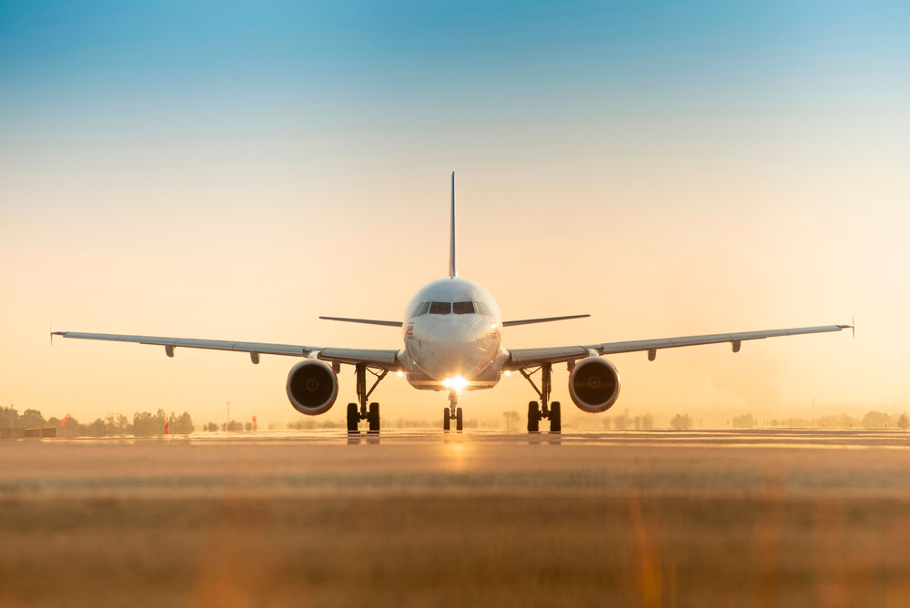

**Índice**

* [What is **air transport**](https://www.itaerea.com/air-transport#air-transport)
  + [**Characteristics** of air transport](https://www.itaerea.com/air-transport#characteristics)
  + [What can be transported **by air**](https://www.itaerea.com/air-transport#by-air)
* [**History** of air transport](https://www.itaerea.com/air-transport#history)
  + [Its development in the **20th century**](https://www.itaerea.com/air-transport#20th-century)
  + [Air transport **today**](https://www.itaerea.com/air-transport#today)
* [Air transport in **logistics**](https://www.itaerea.com/air-transport#logistics)
  + [How does the **logistics chain** for air transport work?](https://www.itaerea.com/air-transport#logistics-chain)
* [**Types** of air transport](https://www.itaerea.com/air-transport#types)
  + [Air freight transport](https://www.itaerea.com/air-transport#air-freight)
  + [**International** air transport](https://www.itaerea.com/air-transport#international)
  + [Air transport of **dangerous goods**](https://www.itaerea.com/air-transport#dangerous-goods)
* [**Means** of air transport](https://www.itaerea.com/air-transport#means)
  + [**Helicopter**](https://www.itaerea.com/air-transport#helicopter)
  + [**Airplane**](https://www.itaerea.com/air-transport#airplane)
  + [**Plane**](https://www.itaerea.com/air-transport#plane)
  + [**Hot air balloon**](https://www.itaerea.com/air-transport#hot-air-balloon)
  + [**Airship or Zeppelin**](https://www.itaerea.com/air-transport#zeppelin)
  + [**Paragliding**](https://www.itaerea.com/air-transport#paragliding)
  + [**Paramotor**](https://www.itaerea.com/air-transport#paramotor)
  + [**Cableway**](https://www.itaerea.com/air-transport#cableway)
  + [**Ultralight or microlight**](https://www.itaerea.com/air-transport#ultralight-microlight)
  + [**Rocket**](https://www.itaerea.com/air-transport#rocket)
* [Air transport **classification**](https://www.itaerea.com/air-transport#classification)
  + [**National and international** flights](https://www.itaerea.com/air-transport#national-international)
  + [**Regular and non-regular** flights](https://www.itaerea.com/air-transport#regular-non-regular)
* [**Importance** of air transport](https://www.itaerea.com/air-transport#importance)
* [**Advantages and disadvantages** of air transport](https://www.itaerea.com/air-transport#advantages-disadvantages)
  + [**Advantages**](https://www.itaerea.com/air-transport#advantages)
  + [**Disadvantages**](https://www.itaerea.com/air-transport#disadvantages)
* [Air transport **infrastructure**](https://www.itaerea.com/air-transport#infrastructure)
  + [**Main airports** in the world](https://www.itaerea.com/air-transport#main-airports)
* [**Impact** of air transport on the environment](https://www.itaerea.com/air-transport#impact)
  + [**Solutions** to mitigate this problem](https://www.itaerea.com/air-transport#solutions)
* [Main **master's degrees** and courses of ITAérea](https://www.itaerea.com/air-transport#masters-courses)

## What is ****air transport****

Air transport is the activity that allows the transfer of people, merchandise and mail in aircraft. Therefore, we are talking about the type of transport that travels by air and is present in airports.

### ****Characteristics**** of air transport

The physical infrastructure necessary for the organization of this means of transport are the airports. Therefore, these facilities are what allow aircraft to take off, land and park safely. In addition, as in the ports, they have the delimitations for the loading and unloading of merchandise, and the embarkation and disembarkation of passengers. Also, they have the necessary space for their maintenance and refueling.

The main characteristics and advantages of air freight transport are speed, reliability in terms of cargo security, lack of access limitations to remote locations. However, it has drawbacks or disadvantages in terms of higher cost, possible bureaucratic or legal limitations, and technical limitations due to the size and capacity of the aircraft.

### What can be transported ****by air****

First of all, commercial aviation allows the transport of people. Second, air freight is one of the most widely used modes of transport. Although it is true that it is a type of transport with a high cost, speed is its most outstanding advantage. And it is that there are goods, which, by their very nature, can only and exclusively be transported by air, such as:

* General merchandise: It does not require special treatment on the aircraft or in the cargo terminal. These are products whose fragility is not too high, and whose value makes exporters choose to bring them by air.
* Perishable goods: Perishable goods are those that deteriorate after a period of time due, for example, to weather conditions, shock or humidity. In this way, fresh foods (meat, fish, fruits, vegetables) or flowers and plants are perishable goods.
* Pharmaceutical goods: We refer to medicines, vaccines or pharmaceutical products. In the same way, as in the case of perishable goods, pharma products often require extensive temperature control.
* Dangerous Goods (DG): As their name indicates, they are those products that can cause harm to human health and/or the environment, such as explosives, flammable gases, liquids or solids, or toxic substances. In this way, this type of merchandise can only be transported by air.
* Urgent goods: As we mentioned at the beginning, one of the main advantages of air transport is speed, for this reason it is ideal for urgent goods, that is, those that have to reach their destination as soon as possible.
* Goods of value: These are those that have a high economic value. Although the ship is a safe means of transport, the plane offers greater guarantees. Some examples of valuable goods are jewelry, precious stones or certain works of art.

## ****History**** of air transport

Its history dates back to 1700, with the creation of the hot air balloon. This invention was created by the Montgolfier brothers, and the first public demonstration was held on June 4, 1783 in France.

After this first "prototype", others were developed to transport passengers through the use of hydrogen as the main fuel. It was the only invention capable of flying through the skies for two more centuries since its creation. This invention was known as the “passenger balloon”.

### Its development in the ****20th century****

Later, in the 20th century, the Wright brothers appeared. Orville and Wilbur Wright were two aviation pioneers, aviators, and engineers. They built the world's first airplane, though to make it fly, they had to create an external catapult to get their invention off the ground.

Next, it was in 1906 when the Romanian inventor Traiana Vuia managed to create the first self-propelled aircraft that could fly.

The next step in the history of the evolution of air transport occurred as a consequence of the development of propeller planes and helicopters in World War II. This meant that it was during the second half of the last century that the development of aircraft really began to take off as a sector.

From there, the industry managed to create planes as fast as the speed of sound. In fact, some of the most famous inventions in this field are the famous Concorde and Boeing 747.

### Air transport ****today****

Currently, all countries have different airports. With the tourism boom and the search for new experiences, this sector found a niche in which to grow. In fact, it is one of the means of transport most used by passengers during their vacation periods and to go to business appointments.

However, as a consequence of the agility and speed it generates, it is also being used more and more as a means of transporting goods. It has even become the preferred means of transport for sending specific, high-cost or urgently received products.

## Air transport in ****logistics****

Air logistics has become an almost indispensable element of foreign trade both due to the high value of some goods and the immediacy of delivery demanded by end customers.

The use of this type of transport works best for perishable or very high value products, which require a quick replenishment and those whose buyers demand an urgent delivery.

In recent years, the rise of e-commerce has increased the demand for air service as consumers have become demanding with delivery times and security, and their satisfaction has become an element of competitiveness for companies.

### How does the ****logistics chain**** for air transport work?

The logistics chain of air freight transport is made up of the set of successive and consecutive physical and documentary processes carried out by the companies involved in the transport of goods by air.

We must begin by identifying who are the users of air freight transport. Users of air freight transport are all those persons, natural or legal, who need to transport merchandise by air and which we will identify as:

At origin: Shipper or dispatcher.

At destination: Consignee or recipient.

The importance of the user lies in the fact that he is the one who defines the demand, whose characteristics must be well analyzed and evaluated.

The logistics chain begins at the moment in which the shipper proceeds to send the consignment, which includes one or more packages of merchandise accepted by the carrier, delivered simultaneously and in the same place, and consigned to a single recipient, called the consignee. or importer.

The consignor is the person whose name appears in the name of the transport contract as a party that establishes the shipment of the merchandise with the carrier. The transport is carried out as a result of a commercial operation that requires the supply of the merchandise and its destination in favor of the importer or recipient.

The sender can carry out the operations with its own means or by contracting the services of an agent, but today, such has been the degree of complexity these operations have reached that companies specialized in this branch of service are generally used.

Once the service contract has been signed, both with a land carrier and a forwarding agent or an integrator, the selected company manages the freight of the merchandise to the airport facilities, proceeding at that time to its consolidation for export.

Subsequently, the integrator proceeds to prepare all those documents required to export the goods.

The documentation is delivered to the customs administration, where certain controls are carried out, depending on the goods to be exported.

Once all the administrative procedures have been completed, the handling agents intervene. Firstly, cargo handling, as responsible for cargo handling at the cargo terminal, and later ramp handling, responsible for transporting the merchandise from the cargo terminal to the aircraft and its stowage in the cargo holds.

The air transport service begins with the delivery of the merchandise to the airline.

The contracted airline, or where appropriate the integrator's air operator, carries out the air transport of the merchandise by air to its final destination, at which time the merchandise is unloaded and transported to the cargo terminal by the handling agent of ramp. Once the merchandise is transferred to the cargo handling company, a first check and contrast of the merchandise is carried out at the terminal, based on the information received from the airline that has carried out the transportation of the same.

The freight forwarder / customs agent receives the documentation of the merchandise, and if appropriate, prepares the documentation that he must present to the customs administration.

The documentation generated by the integrator is delivered to the customs services, either using the online services or by submitting it on paper. The customs services proceed alternatively and, depending on the characteristics of the merchandise and its origin, to the removal of the same, the request for additional information or the prior physical inspection.

Once the requirements for lifting the merchandise have been met, it can be delivered by the handling agent, both to the importer himself and to a representative by the person designated as the consignee of the merchandise, and proceeds from that moment on to the distribution until your final recipient.

One of the concepts that is worth highlighting in this logistics chain is that of the door-to-door service, a transport channel in which there is a single interlocutor before the sender of the merchandise and the recipient of the shipment. This figure is the integrator that includes all intermediate processes, both physical and documentary, within your organization. The integrator's management reduces merchandise delivery times by simplifying and coordinating processes, and is supported by sophisticated shipment tracking and control systems.

## ****Types**** of air transport

Many types of classifications can be established around air transport, from the most general ones that can distinguish, for example, the different means of air transport (helicopter, plane, airship, hot air balloon, plane, etc.) to more specific ones, which classify types of air transport according to the type of cargo moved. In this case, three large groups are distinguished:

* Mixed aircraft: carry passengers in the cabin and goods in the hold. The best known are those built by Airbus and Boeing.
* Cargo planes: transport exclusively goods.
* Super transports: aircraft designed to transport large goods.

### ****Air freight**** transport

Air cargo transport is the most recent means of freight transport and has caused a great advance for the logistics sector. A type of transport that year after year sees its turnover grow. Nowadays, it has become one of the most popular means of transporting goods for commercial purposes.

The use of cargo planes for the transport of goods is experiencing a notable increase in recent years. A speed that justifies the higher cost compared to other means of transport such as the boat.

In addition, aeronautical technology is advancing at a dizzying pace, providing aircraft with increasingly more efficient engines in terms of fuel consumption. Thanks to this, it is becoming more and more advantageous and profitable to use them for the international transport of goods.

### ****International**** air transport

The main characteristic of international air transport is that it allows long distances to be traveled in less time when compared to other modes of transport such as sea or land. In addition, international air travel is currently one of the safest means of travel, although it is also more expensive than other forms of transport. The world organization that brings together the entire air transport industry is IATA, the International Air Transport Association.

Thanks to the speed developed by airplanes, international air transport is today key to the exchange of goods worldwide and to the mobility of people anywhere in the world.

The possibility of traveling long distances in a few hours allows any exporting or importing company to send or receive cargo, merchandise or goods that may be of vital importance for the supply of an industry or for the supply of a population, for example. In addition, international air transport makes it possible to cover markets throughout the world.

As the plane is the fastest means of transport for the development of international trade operations, it is essential in today's logistics chains.

The majority of large productive industries, such as the automobile industry, are characterized by continuous supply and a tense flow to avoid or minimize the storage of parts, components or merchandise. For this reason, these industries need goods to be delivered at the exact time they need.

International air transport services allow industries continuous just-in-time supply, as well as the dispatch and rapid shipment of products by air to any part of the world.

Air transport is currently used in almost all industrial sectors and distribution chains. Most companies use air transport to market goods and products internationally or to deliver samples and documents related to foreign trade operations.

### Air transport of ****dangerous goods****

Dangerous merchandise is any substance or product that during its manufacture, handling, transportation, storage or use can generate or release substances that are harmful to human health and the environment. Matter that can generate ionizing radiation in quantities that can cause injury to people who come into contact with it is also classified as dangerous.

For the transport of these goods it is necessary to carry out a classification according to their chemical characteristics and their degree of danger. The most problematic materials, explosive and radioactive, require express authorization by the relevant authority.

Air transport requirements are more restrictive than other means of transport. Air transport of dangerous goods is generally multimodal. That is, two different means of transport are used: land and air. It must meet the requirements for the transport of dangerous goods by road (ADR) and by air (ICAO Technical Instructions). Within the air, the requirements are more restrictive:

* Only transport in packages is allowed.
* It has greater packaging restrictions.
* The maximum quantities authorized per package are lower.

**International regulations:**

ICAO Annex 18 and its Technical Instructions on the Safe Transport of Dangerous Goods by Air. The States incorporate the provisions of the Technical Instructions into their national legislation and, in some cases, impose additional restrictions (State Variations).

Status Variations are always more restrictive than dispositions. They apply to the transport of dangerous goods by air to, from, or through the entire territory under the sovereignty of the notifying State to all operators and outside its territory to all State operators. European Regulation: Establishes that the transport of dangerous goods by air must be carried out in accordance with Annex 18 of the ICAO and its Technical Instructions.

**IATA Dangerous Goods Regulations**

It is the one normally used by the air transport industry in all operations related to the air transport of dangerous goods and fully complies with the legal standards established in the ICAO Technical Instructions, it contains some differences based on operational considerations, more restrictive than those of ICAO, includes procedures and forms intended to facilitate exchange between airlines Carriers may in some cases impose additional restrictions (Carrier Variations). The variations of the operators must not be less restrictive and are applicable to all the transport carried out by the operators concerned.

**Responsibilities of the two parties: shipper and operator**

Different operators act in any freight transport process, each with their own safety responsibilities. In the case of air transport of dangerous goods, the two most important are:

1. The consignor:

* Ensure that all requirements applicable to air transport are met.
* Inform your employees, as well as train them properly.
* Ensure that the articles or substances are not prohibited for transport by air.
* Properly identify, classify, pack, mark, label, and document shipments.
* Comply with the applicable regulations established by the States of origin, transit and destination.

2. The operator:

* Acceptance, storage, loading and stowage.
* Inspection of possible losses or breakdowns.
* Provision of Information.
* Prepare reports, notification of incidents/accidents.
* Conservation of documents.
* Provide adequate training to all its employees.

## ****Means**** of air transport

When transport and types of transport are discussed, the most common is to mention the most well-known and recognized forms of transport: road, air, sea and, to a lesser extent, the railway.

It is true that these four modes are the main types of transport that exist today, we can also find other more minority forms and classes of transport, but in all of them the base is one of these four types of transport.

Below, we list the different means of air transport that exist:

### ****Helicopter****

Suspended in the air by its powerful rotating blades, the helicopter is one of the most sophisticated flight devices invented by man, endowed with vertical takeoff and landing and relative load and maneuver capacity.

### ****Airplane****

Airplanes are one of the greatest prides of human engineering, as they allow the mass transport of people and cargo over enormous distances and long flight times, at great heights, pushed by one or more propeller or jet engines.

### ****Plane****

Also known as a light aircraft, it is any winged aircraft whose takeoff weight does not exceed 5,670 kilograms. They allow the transfer of personnel and cargo smaller than an airplane and over shorter distances.

### ****Hot air balloon****

It is made up of a manned cabin that suspends a mass of gas in the air, whose heating or cooling allows it to handle the desired altitude, but which moves from the action of the winds, since it lacks propellants.

### ****Airship or Zeppelin****

Unlike the balloon, this ship is suspended in the air through a set of gases less dense than the atmosphere, but controls its direction from a set of propellers similar to those of the helicopter. It was the first flying device to carry out a long-term journey at the beginning of the 20th century.

### ****Paragliding****

A light glider with capacity for one or two people, which does not have an engine and moves from the wind currents, using a flexible wing. The traction of a motor vehicle is often used to make it take off, and a certain height is required to fly it.

### ****Paramotor****

Propelled relative of the paraglider, it has a propeller motor and a flexible wing, with which to take off and stay in mid-flight. It is a kind of motorized paraglider.

### ****Cableway****

Although it does not fly freely, the cable car is a system of cabins that move through the air, attached to a series of cables that are responsible for moving them through various stations. In this way you can fly over mountains, schisms or entire cities, but never outside the previously established route.

### ****Ultralight or microlight****

Light weight and low fuel consumption sports aircraft, equipped with a single or two-seater open cabin and standards without a fuselage or fairing. It has a unique motor with which it is sustained and a being of wheels to take off to the race.

### ****Rocket****

The rocket is the only one of these means of air transport that can overcome the atmosphere and leave the planet Earth. Its combustion engine gets its thrust from the violent expulsion of gases.

## Air transport ****classification****

A generic classification is the one that divides air transport into: regular or non-regular, national or international. We look at each of these types of air travel.

### ****National and international**** flights

In most cases, transportation between two points that are within the borders of the same state is considered domestic.

Excluded from this classification are those flights that, although they are made between two points in the same state, the aircraft must fly over the territory of another state.

Therefore, such a flight is subject to international law. International transport is one that is carried out between two points that are in the territories of different states.

### ****Regular and non-regular**** flights

Another classification of types of air transport is based on the way in which the transport is carried out. Thus, a flight is understood as regular when it meets the following conditions:

* That it is carried out between two or more different traffic zones and its characteristics do not vary, in essence, throughout the time in which it is programmed.
* That its schedule is public and fixed, as well as the frequency, the itinerary and the price.
* That it be done for profit.
* Make it accessible at all times to anyone.

Non-regular transport is understood to be that which is first contracted in view of a need, and then carried out.

There is therefore a charterer and a carrier, which is the one that carries out the air transport of passengers and their belongings (checked baggage in the hold and hand luggage).

## ****Importance**** of air transport

The importance of air transport lies in its ability as an economic engine to generate and support jobs, strengthen trade and connectivity between people and countries, promote tourism, and connect remote communities.

The undoubted economic and social benefits of aviation are clear, with the growth of the sector being important for all countries, developed and developing. However, these benefits also come at an environmental cost. For aviation to grow sustainably, it is vital that the industry balance the benefits of air travel growth with the responsibility to take action on climate change.

Air connectivity also enables social connection and inclusion and the promotion of the exchange of knowledge and ideas. In the same way, it encourages increased productivity, improved efficiency and favors innovation.

## ****Advantages and disadvantages**** of air transport

The main characteristics and advantages of air freight transport are speed, reliability in terms of cargo security, lack of access limitations to remote locations. However, it has drawbacks or disadvantages in terms of higher cost, possible bureaucratic or legal limitations, and technical limitations due to the size and capacity of the aircraft.

### ****Advantages****

* Speed: it is the fastest mode of transport that exists and, therefore, it is especially recommended when time is an important factor.
* There are no physical barriers: thanks to this it is possible to make a trip without interruption choosing the shortest and most direct route through seas, mountains.
* Easy access: Air transport can transport goods to areas that are not easily accessible by other means of transport.
* Suitable for transporting high-value or perishable goods over long distances.

### ****Disadvantages****

* Very expensive economically: it is the most expensive means of transport.
* Uncertain: air transport is largely conditioned by weather conditions. Snow, rain, fog, etc., can cause the cancellation of scheduled flights and the suspension of air service.
* Not suitable for cheap and high volume goods due to its limited capacity and high cost.
* Legal restrictions: Many countries have legal restrictions in the interest of their own security.

## Air transport ****infrastructure****

An essential part of the air transport system is represented by airports, which provide all the necessary infrastructure to make it possible for passengers and cargo to be transferred from the surface to the different air modes of transport and for airlines to carry out their takeoffs. and landings. The basic airport infrastructure is made up of runways, taxiways, aircraft parking areas, boarding bridges, passenger and cargo terminals, and ground transportation interchanges.

Currently, air transport is a sector characterized by being one of the fastest growing in the world economy. This explosive increase constitutes a challenge for airports in terms of capacity development and management. Likewise, the airport sector is not the same as it was a few decades ago, when airport infrastructures operated like any other public service. Now it is a dynamic and competitive sector, and the companies that form it have begun to exploit their commercial side and, therefore, to operate as a business with the obligation to generate income. That is, to operate more efficiently.

### ****Main airports**** in the world

Of the 46 airports and 2 heliports managed by AENA, the main airports in Madrid and Barcelona cover more than 40% of the country's total passengers. At a European level, Spain ranks as the third country in the European Union in number of air passengers thanks to the airports of Madrid, Barcelona and Palma de Mallorca.

The Adolfo Suárez Madrid-Barajas airport is the gateway between Europe and Latin America (26% seats offered); Madrid is the capital of Spain, and the Adolfo Suárez Madrid-Barajas airport is the gateway for tourism in the country.

The Adolfo Suárez Madrid-Barajas airport is connected to most of the country's tourist destinations (28 Spanish airports), with 192 international destinations (+5,000 passengers) from 73 countries, and has 83 airlines (+5,000 passengers), with a presence all alliances: One World, Sky Team and Star Alliance.

Josep Tarradellas Barcelona-El Prat airport is connected to 212 destinations (+5,000 passengers), of which 137 are European destinations and has 89 airlines (+5,000 passengers), with all alliances present: One World, Sky Team and Star Alliance.

## ****Impact**** of air transport on the environment

It is estimated that the commercial aviation sector is responsible for 2% of the greenhouse gases generated by human activity that are released into the atmosphere and 3% if other polluting gases are included.

This impact will increase over the years. According to Airbus forecasts, the number of passenger aircraft in 2034 will double that of 2014, reaching 35,749 units (of which more than 31,000 have not yet been built).

### ****Solutions**** to mitigate this problem

The air transport industry must acquire a firm commitment to face the challenges arising from its growth and its impact on the sustainability of the planet. Those directly responsible for this fight are mainly aircraft manufacturers, airlines, airport managers and ancillary companies.

To mention two specific cases of airlines, in terms of climate action, Iberia develops different initiatives that seek to improve the efficiency of carbon emissions, with the aim of minimizing the environmental impact. Projects that contribute to a lower impact in terms of climate change are the renewal of the fleet, with the incorporation of the Airbus A-300-200 that are used on long-haul international routes, a final saving of 15% of kerosene per plane is achieved ; or the renewal of ground equipment, aircraft assistance vehicles and passengers.

Other projects such as electronic flight documentation or electronic flight bag (EFB), implemented on board short and medium haul aircraft, have simultaneously led to technological improvements from an operational point of view, and savings in fuel and CO2 emissions. due to the reduction in the weight of the plane due to the disappearance of the paper documentation portfolios from the cabins.

On the other hand, the historic milestone achieved by easyJet in reducing CO2 emissions is also worth mentioning. This airline has set itself the ambitious challenge of reducing carbon emissions to 77 grams in 2020, which would mean a reduction of more than 33% in twenty years. For the first time in its history, it has managed to reduce carbon emissions below 80 grams thanks to technological and efficiency improvements in its operations.

Since 2000, when the airline started reporting carbon emissions, easyJet has reduced carbon emissions by more than 31% (from 116.2 to 81.05 grams per passenger kilometer last year to at 79.98 grams today).

## Main ****master's degrees**** and courses of ITAérea

Postgradu

* [Master in Sustainable Air Transport Management MATSM (ONU)](https://www.itaerea.com/master-in-sustainable-air-transport-management-executive-e-learning-modality)
* [Master of Business Administration in Aviation Management e-learning modality](https://www.itaerea.com/master-of-business-administration-in-aviation-management-e-learning-modality)

Courses:

* [Course on Airport International Business Management (for managers)](https://www.itaerea.com/course/airport-international-business-management)
* [Course on Airport Management](https://www.itaerea.com/course/airport-management)
* [Course on Aviation English for the Airport Industry](https://www.itaerea.com/course/aviation-english-airport-industry)
* [Course on Air Law](https://www.itaerea.com/course/aeronautical-law)
* [Course on Air Company Management](https://www.itaerea.com/course/air-company-management)
* [Course on Aeronautical Companies Management](https://www.itaerea.com/course/aeronautical-companies-management)
* [Course on Air Navigation](https://www.itaerea.com/course/air-navigation)

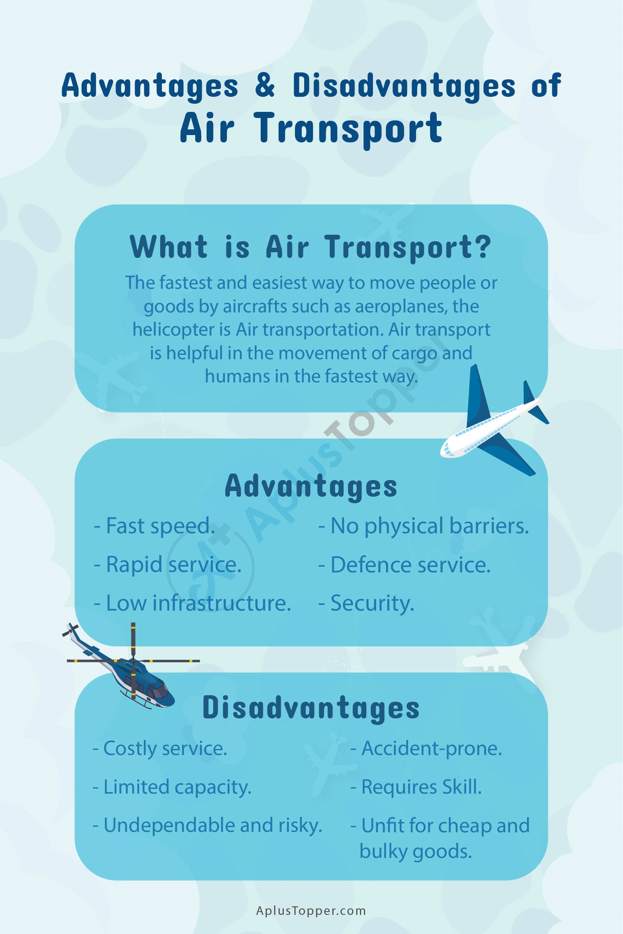

**Advantages of Air Transport**

* Defence service. Airforce service is essential to any nation. ...
* High Speed. Bulky freight and large groups of people may be carried quickly and anywhere globally using air transportation. ...
* Low infrastructure. ...
* Rapid service. ...
* No physical barriers. ...
* Security. ...
* Emergency Services. ...
* Easy Access.

**Disadvantages of Air Transport**

* High Costs: ADVERTISEMENTS: Air transport is a costly service. Its operational costs are too high. ...
* More Risks: Air transport is prone to accidents. A small mistake can be very dangerous for passengers. Hijacking of planes is easily possible.
* Huge Investments:

CONCLUSION

The air transport industry is not only a vital engine of global socio-economic growth but is also of vital importance as a catalyst for economic development in most countries and for many regions within each country. Its importance arises not only from its ability to facilitate the movement of people but also its ability to expedite the movement of goods. Currently, rising operating costs, stoked by the high price of aviation fuel combined with slowing or even negative demand growth, will lead to dramatic restructuring of the airline industry and the collapse of many airlines especially smaller ones. Reduced access to air services for both passengers and freight may put many communities at a disadvantage.